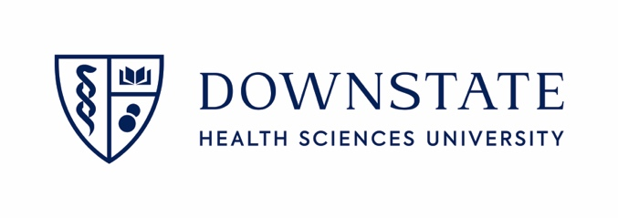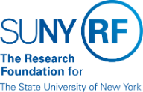
1st Annual SUNY Downstate: Clinical Trials Symposium

Wednesday, October 25th, 2023, PHAB 1st Floor, Halls A-D
8:30AM – 4:00PM

The DHSU Clinical Trials Symposium aims to strengthen and catalyze clinical trials on campus. Hear about new and current research endeavors, foster new collaborations, and strategize on how to improve clinical trial activity at Downstate.

Symposium Agenda

8:30am Registration and Breakfast
9:00am Welcome and Introduction
Yihenew Abetu, Director, Clinical Trials division
9:10am Opening Remarks
Dr. David Christini, SVP for Research
Dr. David Berger, Chief Executive Officer, University Hospital
9:20am Introduction of Keynote Speaker
Dr. Charles Brunicardi, Dean, College of Medicine
9:30am Keynote Address
Presentation by Keynote Speaker (External)
Dr. John Boockvar MD – Neurosurgeon/Downstate Allum
      - John Andrew Boockvar, MD | Northwell Health
      - Lenox Hill (TV series) - Wikipedia
10:15am Q&A

10:30am Session 1: [Clinical Trials & TriNetX]
Speaker 1: ORA Team – Research infrastructure
Sharon Sealy, Executive Director, ORA
Yihenew Abetu, Director, Clinical Trials division

10:45am Speaker 2:
John Esposito, Senior Director, TriNetX
11:00am Speaker 3:
Dr. Tom Wallach, Assistant Professor, Pediatric Gastroenterology

11:15am Q&A
11:30am Lunch Break & Networking
1:00pm Breakout Sessions
Session 1: [IRB]
Kevin Nellis, Executive Director, Human Research Protections

  - Applicable Clinical Trials and PRS reporting (CT.gov)
  - Using an External IRB
  - What’s new with the IRB
  - Audience Q&A

Session 2: [CTAC, SLS]
Dr. Steve Levine, Professor & Vice-Chair, Neurology

- Introduction of CTAC and what is their charge – Dr. Levine
- Strategic Planning on moving CTs forward at Downstate
  - Resources: CRCs, Space, protected time, strategically what do Physicians need?
Session 3: [Diversity in CTs]
Dr. Marcus Lambert, AVP for Research and Strategy & Operations

Panel – [recruitment, enrollment]
  - Erica Courtenay-Mann, Sarcoidosis Patient Advocate
  - Dr. Marilyn Fraser, Chief Executive Officer, Arthur Ashe
  - *Alishia Goodridge, AVP for Government & Constituent Relations
  - Dr. Moro Salifu, Professor & Chair, Department of Medicine
2:00pm SUNY & RF Mission – Increasing Trials Across the Enterprise
Panel Discussion:
*Kristen Fry, Director Clinical Vision Research Center at SUNY College of Optometry
- Coordinator training
- How other campuses approach CTs?
Scott Shurtleff, VP, Sponsored Programs Services
      - CTFG
      - Master Contracts
      - Streamlined Training of Coordinators
Yihenew Abetu, Director, Clinical Trials division
- WCG
3:00pm Future Perspectives & Closing Remarks
Summary and Reflections, Sharon Sealy

Thank You to Attendees, Speakers, and Organizers, Dr. David Christini
- Announcement of Future Events or Follow-Up Activities
3:30pm Reception & Informal Networking

*Invited

