POLICY & PROCEDURE

UNIVERSITY HOSPITAL Prepared by: Stephen Kitynsky No. LAB-32
SUNY HEALTH SCIENCE
CENTER AT BROOKLYN Reviewed by: Dynesdal Wint Issue Date: 11/04
450 CLARKSON AVENUE Alix R. Laguerre
BROOKLYN, NY 11203 Approved by: Anthony Nicastri, MD Supersedes: 11/07
Peter J. Howanitz, MD Review Date: 10/08

SUBJECT: PROCEDURE FOR ACCESSING LIS COPATH

POLICY:

All clinicians (i.e. authorized non-Anatomical Pathology personnel) at SUNY-DMC-UH) may access the Dynamics CoPath L.I.S. system. The person should have access to a PC loaded with the CoPath-Plus L.I.S. (Live CoPath). At present, CoPath and Cerner are two separate and independent systems.

The hospital personnel should come to the Anatomical Pathology Office (UH, A2-466) to obtain a CoPath User ID and Password.

Clinicians’ access is limited to:
- Clinician Inquiry (for a patient)
- Print Patient Reports (Final, Addendum, and/or Additional Procedures)
- Password Changes (change your own password at anytime).

PROCEDURE:

- Logon to CoPath using your User ID and Password. The following window will appear.

B. If you choose to access the Clinician Inquiry
- Select the Inquiry, Clinician on your menu
(on left side of Application Manger).
  - The following window will appear:

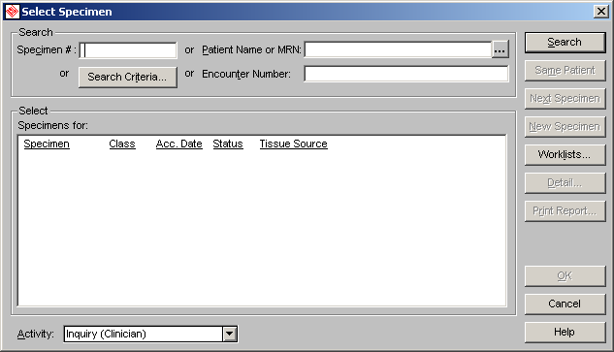

  - You may find the patient you are interested in by entering one of the following in the same designated area:
.
    - Patient Name (Last Name, First Name) -or-
    - Medical Record Number (MPN)
- Depending what was entered one or multiple cases will appear.
- Select (scroll to) the patient you are interested in.

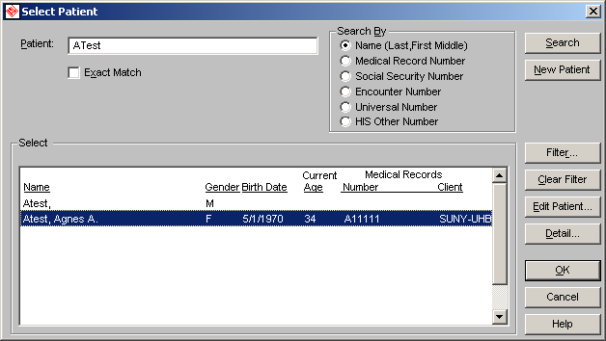

- Click the OK button.
- A list of cases associated with the selected patient will appear.

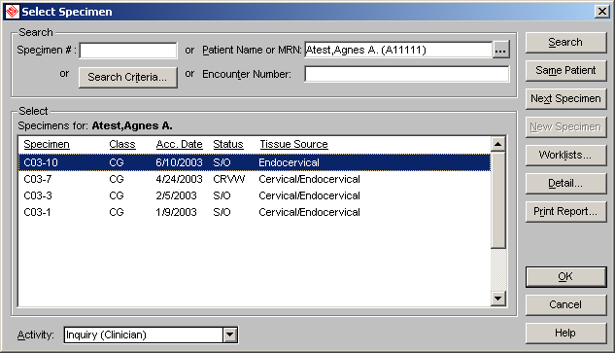

- Select (scroll to) the case you are interested in.
- Click the OK button.
- The following information will appear.

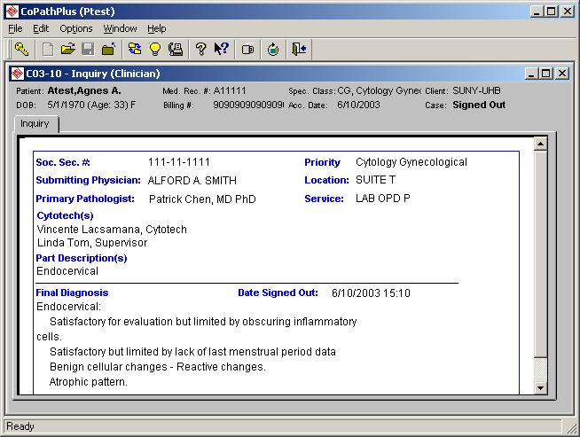

C. If you want to print the full report on the patient, you must have a laser printer at the PC location.

↑
Select this icon to print the report you want.

- Select to print the Final Report. Click Print/Send

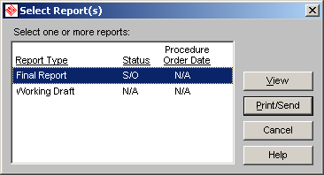

- From the Print/Send Setup window, select the correct printer code to print to the printer you want.

- CoPath will alert you that the print job has been sent to the printer and return when finished.
- You may return to the main window setting by clicking the X box (at the upper most right corner).
- You may exit CoPath by clicking the X box (at the upper most right corner) and answer the pop-up message request.

Signature of Supervisor: ______________________________ Date: _________________

