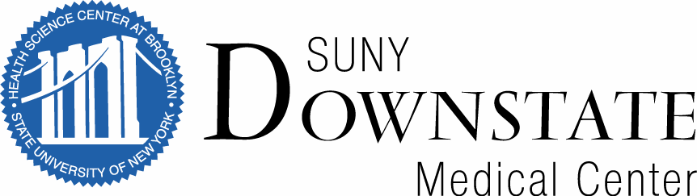

Shevde Family Scholarship Fund   
for Medical Students in Anesthesia Research   
Description for Scholarly Oversight Committee

The objective of the **Shevde Family Scholarship Fund for Medical Students in Anesthesia Research** is to support SUNY Downstate medical students who are in good academic standing, who have successfully completed at least their MS 1 year, and who show interest in conducting research. The fund provides up to $6,400 per year awarded to two students at $3200 each. The scholarships will support anesthesiology research, which may include: training in scientific methods and techniques, and/or learning how to incorporate research into a medical career. Students are expected to participate in research and training activities by working closely with an experienced investigator – research mentor. This research experience would be conducted over an 8-week period.The recipients of the scholarship will have the opportunity to present a poster at the American Society of Anesthesiologists annual meeting in October, the NYSSA Post Graduate Assembly annual meeting in December or other appropriate subspecialty meetings. Participating students will be required to submit summaries of their research experience to the Vice-Chair for Research within one month of completion.

*This research experience is not eligible for research elective credits.

**APPLICATION PACKET**

The following materials are required for all **Shevde Family Scholarship Fund for Medical Students in Anesthesia Research** student applications (checklist)

Contact, background & academic information

Name and contact information

Up-to-date CV that summarizes applicant’s educational background, professional experience, any honors, awards, and outside interests

Downstate transcript

MCAT scores

Questions (250 words per question)

Prepare thoughtful responses to each of the three questions. Your responses should demonstrate your interest in research with an emphasis in anesthesiology and perioperative medicine. There is no prerequisite for this award – no previous research experience in anesthesiology is required and no future commitment to anesthesiology residency is required.

Question No. 1: List any clinical and/or research experiences you have had in anesthesiology or perioperative medicine.

Question No. 2: List any past research experiences, publications and/or presentations. Please include dates and the names of the project leads, if applicable.

Question No. 3: In 250 words or fewer, describe, as well as possible, aspirations for professional life following medical school graduation and what role anesthesiology may play in your career.

Letters of Recommendation

Two letters of recommendation that evaluate applicant’s quality of character, academic performance, and interest in a career in research. At least one of these letters should be from SUNY Downstate faculty. Attached sealed letters or request that the recommenders email or mail the letters to the research coordinator.

Letter of good standing

A letter of good standing from the SUNY Downstate Dean of Student Affairs that confirms the applicant’s enrollment and good standing for the duration of the fellowship.

**TIMELINE**

Applications accepted starting: March 1st, 2020

Applications due: March 30th, 2020

Award notifications made by: April 22th, 2020

Deadline to accept award: April 30th, 2020

Fellowship begins: Summer 2020 [exact date determined with faculty mentor]

Accepted applicants who wish to be considered must submit documentation by email to the Research Coordinator, Mauricia Victor, MS, MPH: [mauricia.victor@downstate.edu](mailto:mauricia.victor@downstate.edu), by mail to The Department of Anesthesiology, c/o Mauricia Victor, 450 Clarkson Avenue, Box 6, Brooklyn, NY 11203, or to room B3-331 if they are on campus.

**Evaluation of Student Applications**

Student applications for **Shevde Family Scholarship Fund** **for Medical Students in Anesthesia Research** are reviewed by the Department of Anesthesiology Scholarly Oversight Committee.

**Scholarly Oversight Committee Membership:** Chaired by the Vice Chair for Research – Dr. Shevde, members: Dr. Cottrell, Dr. Bendo, Dr. Wlody, Dr. Kass, Dr. Hartung, Dr. Rushbrook, Dr. Zhang, Dr. Worah, Dr. Dimaculangan, Dr. Velickovic.

Each member of the committee will rate all parts of application packets and applicants’ academic information based on scoring guidelines (academic achievement, CV evaluation of undergraduate and medical school activities, research experience, publications, anesthesia interest/career trajectory, letters of recommendation) and generate an aggregate score for each applicant using a scoring sheet. Each application will then get an average score based on all scores from SOC members. It is anticipated that the two highest scoring applications will be awarded. In the event of a score tie, potential recipients may be interviewed.

**AWARDEE RESPONSIBILITES**

During the academic year, participating students will be required dedicate 37.5 - 40 hours per week for 8-10 consecutive weeks to work closely with a faculty mentor and participate in research and didactic activities within the anesthesiology department. During this time, they will also be encouraged to spend at least one week in clinical anesthesia settings (e.g., operating room, labor & delivery room). These responsibilities should not conflict with students’ academic responsibilities.

**Optional, but highly recommended**: Work closely with the assigned mentor to submit an abstract to ASA annual meeting in October, NYSSA Post Graduate Assembly annual meeting in December or to other appropriate subspecialty meetings.

**AWARD CHECK DISTIBUTION**

Recipients will be mailed two checks in the amount of $1,600 -- first at 4-weeks of the fellowship and the second at the end of the fellowship, for a total of $3,200 -- and will be subject to satisfactory completion of the required scholarly activities.