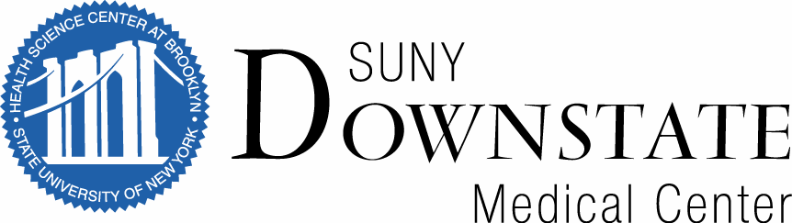**Shevde Family Scholarship Fund   
for Medical Students in Anesthesia Research**

The objective of the **Shevde Family Scholarship Fund for Medical Students in Anesthesia Research** is to support SUNY Downstate medical students in good academic standing, who have successfully completed at least their MS 1 year and who show interest in conducting research. The fund provides up to $6,400 per year awarded to two students at $3,200 each. The scholarships will support anesthesiology research, which may include: training in scientific methods and techniques, and/or learning how to incorporate research into a medical career. Students are expected to participate in research and training activities by working closely with an experienced investigator – research mentor. This research experience will be conducted over an 8-week period.The recipients of the scholarship will have the opportunity to present a poster at the American Society of Anesthesiologists annual meeting in October, the NYSSA Post Graduate Assembly annual meeting in December or other appropriate subspecialty meetings. Participating students will be required to submit summaries of their research experience to the Vice-Chair for Research within one month of completion.

RECIPIENT RESPONSIBILITES**.** Participating students will be required to dedicate 37.5 - 40 hours per week for 8 consecutive weeks to work closely with a faculty mentor and participate in research and didactic activities within the anesthesiology department. During this time, they will also be encouraged to spend at least one week in clinical anesthesia settings (e.g., operating room, labor & delivery room).

*This research experience is not eligible for research elective credits. Scholarship payments will be subject to satisfactory completion of the required scholarly activities. There are no prerequisites for this award -- no previous research experience in anesthesiology and no future commitment to anesthesiology residency is required. Only complete applications will be reviewed.

CHECKLIST. All applicants must submit:

Application Section A: Contact, background and academic information

Application Section B: Answers to three questions about research interests and experiences

Application Section C: Two letters of recommendation

Applications will be accepted starting March 1st, 2020 and the **deadline for submission is March 31st, 2020**.

Accepted applicants who wish to be considered must submit documentation by email to the Research Coordinator, Mauricia Victor, MS, MPH: [mauricia.victor@downstate.edu](mailto:mauricia.victor@downstate.edu), by mail to The Department of Anesthesiology, c/o Mauricia Victor, 450 Clarkson Avenue, Box 6, Brooklyn, NY 11203, or to room B3-331.

Award notifications will be sent by April 22nd, 2020. Selected applicants will have until April 30th, 2020 to accept the scholarship. They will then be contacted to make arrangements about the timeframe of the research experience and faculty mentor match.

**Shevde Family Scholarship Fund   
for Medical Students in Anesthesia Research**

**Section A: Contact & Background Information**

Last Name First Name Middle Name

Street Apt. Number

City State Zip

Phone Email

Year in Medical School: MCAT scores: ____________________________________

**CV and Copy of Transcript.** Please provide an up-to-date CV and the copy of your SUNY Downstate transcript. CV should summarize your educational background, professional experience, any honors, awards, and outside interests. Student copy of transcript can be obtained through the Registrar Office free of charge. Attach to this application.

**Section B: Questions.**

Prepare thoughtful responses to each of the three questions. Your responses should demonstrate your interest in research with an emphasis in anesthesiology and perioperative medicine. There are no prerequisites for this award -- no previous research experience in anesthesiology and no future commitment to anesthesiology residency is required. Please attach typed responses with your application.

Question No. 1: In 250 words or fewer, list any clinical and/or research experiences you have had in anesthesiology or perioperative medicine.

Question No. 2: In 250 words or fewer, list any past research experiences, publications and/or or presentations. Please include dates and the names of the project leads, if applicable.

Question No. 3: In 250 words or fewer, describe, as well as possible, aspirations for professional life following medical school graduation and what role anesthesiology may play in your career.

**Section C: Letters of Recommendation**

Provide two letters of recommendation that evaluate your academic performance, interest in a career in research and quality of character. At least one of these letters should be from SUNY Downstate faculty. Attach sealed letters to this application or request that the recommenders email or mail the letters to the research coordinator.

Recommender 1:

Name:

Relationship:

Recommender 2:

Name:

Relationship: