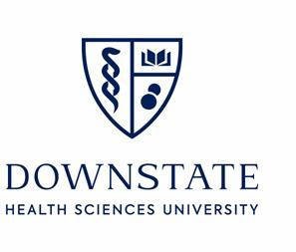

SUNY Downstate Health Sciences University Student Attrition Rate 2023 - 2025

|  |  |  |  |
| --- | --- | --- | --- |
|  | **Graduated Classes** | | |
| **Class of** | **Class of** | **Class of** |
| **2023** | **2024** | **2025** |
| **Maximum entering class size**  (as approved by ARC-PA) | **45** | **45** | **45** |
| Entering class size | **32** | **37** | **38** |
| Graduates | **30** | **31** | **42** |
| **\*Attrition rate** | **6.25%** | **8.12%** | **0%** |
| **\*\*Graduation rate** | **93.75%** | **91.88.%** | **100%** |

*\**Attrition rate calculation: Number of students who attritted from cohort divided by the entering class size.

**Graduation rate: Number of cohort graduates divided by the entering class size.

The program excess number of students was solely due to students who decelerated/leave of absence from previous cohorts, and added to the class, after the incoming class had been accepted and matriculated.