Waist Measurements and BMI November 6, 2007 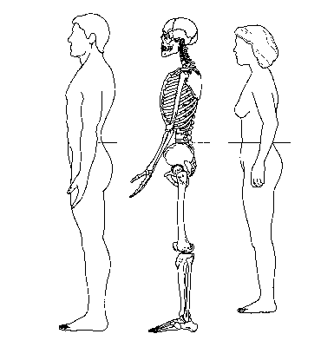

Measuring Tape Position for Waist (Abdominal) Circumference

TO MEASURE YOUR WAIST SIZE

To measure your waist size (circumference), place a tape measure around your bare abdomen just above your hipbone. Be sure that the tape is snug, but does not compress your skin, and is parallel to the floor. Relax, exhale, and measure your waist.

Extra fat in our belly area may put our health at risk, even if we are at a healthy weight. Men who have a waist size greater than 40 inches, and women who have a waist size greater than 35 inches, are at higher risk of diabetes, problems with cholesterol and triglycerides, high blood pressure, and heart disease because of excess abdominal fat. If your waist size is larger than these amounts, you should consider losing weight.

Your healthy weight
Many Americans are overweight. Almost two-thirds of us are. Where do you fit in?
It's fairly easy to tell. One common tool used as an indicator to determine whether you are at a healthy weight is the Body Mass Index, or BMI. Use the BMI chart as an indication of your weight status—underweight, healthy weight, overweight, or obese. Locate your weight in the left-most column, and read across the row from your weight to your height. The number in the middle connecting the two is the BMI. A BMI of less than 19 is underweight, 19 through 24 is the healthy weight range, a BMI of 25 through 29 is the overweight range, and a BMI of 30 and above is the obese range.

According to Waist Circumference

Although waist circumference and BMI are interrelated, waist circumference provides an independent prediction of risk over and above that of BMI. Waist circumference measurement is particularly useful in patients who are categorized as normal or overweight on the BMI scale. At BMIs greater than or equal to 35, waist circumference has little added predictive power of disease risk beyond that of BMI. It is therefore not necessary to measure waist circumference in individuals with BMIs greater than or equal to 35.

From http://www.health.gov/dietaryguidelines/dga2005/healthieryou and http://www.nhlbi.nih.gov/guidelines/obesity

BMI Chart

