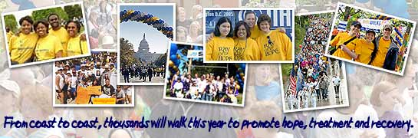
NAMI Walk
Prizes
Get a goodie bag when you sign up!

All walkers will also receive a t-shirt!

Come to the Information Session to be entered to win a door prize!

Information Session
Who: IPS Patients and Staff

Where: 6th Floor Community Room

When: Friday, April 13 at 1 PM
Every journey begins with that first step.
In 2007, thousands of concerned citizens across the nation will join NAMI's “Campaign for the Mind of America” and walk together to raise money and awareness about our country's need for a world-class treatment and recovery system for people with mental illness.
Join the St. Luke’s-Roosevelt Team and you can be one of them!

