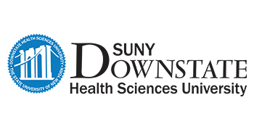

July 1, 2021

To Whom It May Concern,

RE: RESIDENT’S NAME

Please be advised that RESIDENT’S NAME MD, successfully completed his/her specialty residency program at the SUNY Downstate Health Sciences University, a program accredited by the Accreditation Council for Graduate Medical Education (Program ACGME#..... ) on June 30, 2021.

He/She was a resident with this residency Program from July 1, 2016 through June 30, 2020 and graduated in good standing.

Please extent any courtesies to her and for further information, please call me at 718-270-8906 or email at kino.williams@downstate.edu.

Sincerely,

Program Coordinator’s/Director’s NAME
Title

