|  |  |
| --- | --- |
| “ Warmest wishes for a happy holiday season and a wonderful, healthy, happy and peaceful New Year” | Happy Holidays |
|  |  |
| *Clivia Torres, LCSW-R*  BRIDGE Care Manager.  *Viktoriya Donovan, MD* – BRIDGE Program Administrator.  *Sayan Kaishibayev, MD* – BRIDGE Program Evaluator.  *Marilyn Fraser, MD* – Executive Director for the Arthur Ashe Institute,  of Urban Health (AAIUH); serving as Director of the NIH-NIMHD funded  Brooklyn Health Disparities Center Community Engagement Core.  *Tenya Blackwell, PhD* – Director of Community Engagement and Research  Arthur Ashe Institute of Urban Health (AAIUH).    *David Stevens, MD* – Chief of Ambulatory Medicine at NYC Health + Hospitals  Kings County (NYCHHKC).  *Camille Taylor-Mullings, MD* – Chief Medical Officer of the Brownsville Multiservice Family Health Center.    *Claudette Macey* – CEO, Fort Greene Council.    *Elizabeth Helzner, PhD* – Associate Professor in the  Department of Epidemiology and Biostatistics,  School of Public Health.  *Ludmila Ferruzzi, DrPHc, LMSW* –  Teaching Assistant,  Geriatrics Certificate Program,  School of Public Health.  *Carl I Cohen, MD* – Project Director. SUNY Distinguished Service Professor, Director of the Division of Geriatric Psychiatry, CEAD and BRIDGE-GWEP at SUNY Downstate Health Sciences University (SDHSU).  *Michael Reinhardt, MD* - Co-director of BRIDGE. Assistant Professor of Psychiatry, Clinical Assistant Dean, Director of the Geriatric Psychiatry Fellowship, Associate Director of CEAD at SDHSU.  *Everton Prospere, MD, MPH –* Co-director of BRIDGE Program. Clinical Assistant Professor and Director of the SDHSU Geriatric Medicine Fellowship Program.  *Shirley Girouard, PhD, RN, FAAN –* Co-director of BRIDGE. Professor of Nursing and Associate Dean for Research and Innovations in the SDHSU Collage of Nursing.  *Howard Crystal, MD* – Discussant on BRIDGE ECHO. Professor of Neurology, Pathology and Psychiatry at SDHSU and Director of the Memory Disorders Center.  *Steven Levine, MD* – Discussant on BRIDGE ECHO. Professor and Vice Chair of the Department of Neurology at SDHSU  *Tonya Taylor, PhD, MS* – Co-director of BRIDGE. Discussant on BRIDGE ECHO; Anthropologist and Assistant Professor and research member of the HIV Program at SDHSU.  *Karlene Lawrence, DNP, ANP-C* – Co-director of the BRIDGE Interdisciplinary Team (BRIDGE-IT), Nurse Practitioner-Clinical Coordinator.  **Meet the BRIDGE-GWEP Team:** |  |

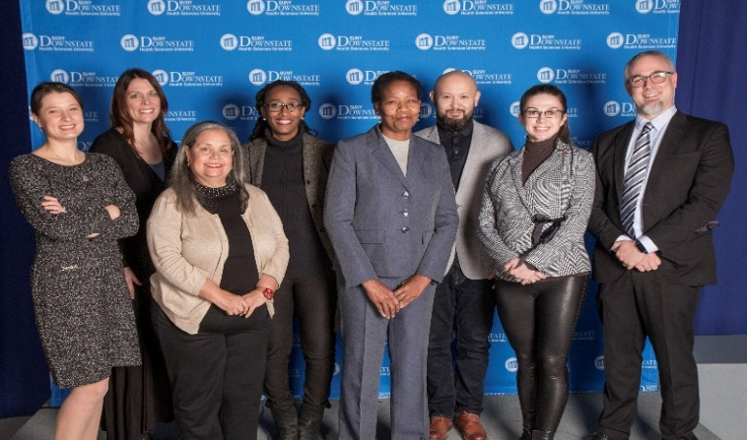

**Br**ooklyn **I**nitiative To

**D**evelop **G**eriatrics **E**ducation (**BRIDGE**)

**H**ealth and **H**uman **S**ervices (**HRSA**)

**G**eriatrics **W**orkforce **E**nhancement **P**rogram **GWEP**)

The **U.S. Department of H**ealthand **H**uman **S**ervices (**HRSA**), awarded a 5-year, grant to **S**UNY **D**ownstate **H**ealth **S**ciences **U**niversity(**SDHSU**), **Department of Psychiatry and Behavioral Sciences**, to prepare physicians, nurses, and other members of the health care team t**o provide comprehensive, integrated physical and mental health services for older adults**. This model service and training initiative will be led by clinical and education experts in primary care, geriatric psychiatry and medicine, and nursing.

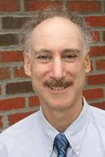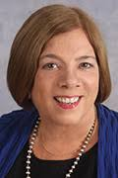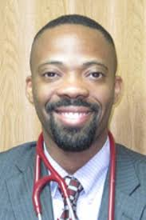

The grant will provide

financial resources to support

the Brooklyn Initiative to Develop Geriatrics Education (BRIDGE), an interprofessional geriatrics education program that includes the **C**ollege **o**f **N**ursing (**CON**), the **D**epartment **o**f **M**edicine (**DOM**), the **Department of Psychiatry**, the **Division of Geriatric Psychiatry**, the **S**chool **o**f **P**ublic **H**ealth (**SOPH**) and the **S**chool **o**f **H**ealth **P**rofessions (**SOHP**), as well as **neighborhood health centers** and **community-based organizations** focused on **Brooklyn’s aging population**.

**Collaboration and Proposal Development**:

The BRIDGE Program is composed of **S**UNY **D**ownstate **H**ealth **S**ciences **U**niversity (**SDHSU**), **Clinical Partners**, **Community Partners**; **and a coordinating Council** that includes: the **SDHSU BRIDGE Team**: two primary care delivery systems in Brooklyn: **NYC Health + Hospitals Kings County** (**NYCHHKC**), the Brownsville Multiservice (**BMS**) Family Health Center; and a large community-based organization: the **F**ort **G**reene **C**ouncil, Inc (**FGC**), which consists of **13 Brooklyn’s Department for the Aging-funded senior centers**.

**BRIDGE-GWEP Coordinating Council**

**BRIDGE-GWEP Team**

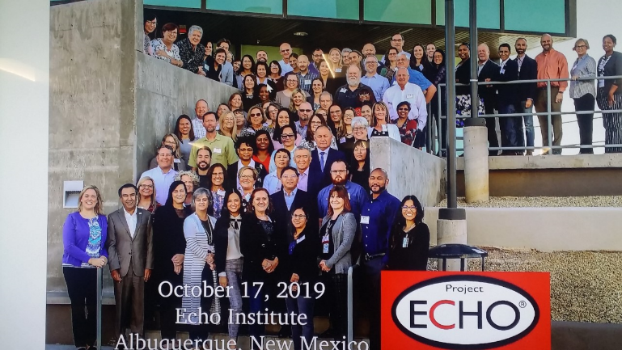

**Fall/Winter Updates**

**On the National Stage**:

**S**UNY **D**ownstate **H**ealth **S**ciences

**U**niversity (**SDHSU**) **BRIDGE-GWEP**

coordinating council staff (**Carl Cohen, MD,**

**Michael Reinhardt, MD, Everton Prospere, MD,**

**MPH, Shirley Girouard, PhD, RN, FAAN, Tonya,**

**Taylor, PhD, MS, Karlene Lawrence, DNP, ANP-C**) attended the November 13-17, 2019 **G**erontological **S**ociety **o**f **A**merica (**GSA**) **Annual Scientific Meeting** in Austin, Texas.

While there, the SDHSU BRIDGE-GWEP staff attended the November 13, 2019 annual, national **HRSA GWEP-CC Preconference Session**, and additional ad-hoc symposium by other **GWEP programs**.

The November 13, 2019 **N**ational **A**ssociation **for Geriatric Education** (**NAGE**)-**N**ational **A**ssociation **of G**eriatric **E**du

cation **C**enters (**NACE**), annual meeting was attended by **SDHSU** members **Michael Reinhardt, Shirley Girouard,** and **Karlene Lawrence**. **Michael Reinhardt** and **Karlene Lawrence**

Volunteered to the  NAGE-NACE **Education  & training  committee**.



*This program is supported by the Health Resources and Services Administration (HRSA) of the U.S. Department of Health and Human Services (HHS) as part of an award totalling $3.75 million with zero percentage (0%) financed with non­governmental sources. The contents are those of the author(s) and do not necessarily represent the official views of, nor an endorsement, by HRSA, HHS or the U.S. Government.*

SUNY Downstate Health Sciences University (HSU), **H**ealth **R**esources **A**dministration(**HRSA**), **B**rooklyn **I**nitiative to **D**evelop **G**eriatric **E**ducation (**BRIDGE**), **G**eriatric **W**orkforce **E**nhancement **P**rogram(**GWEP**)team members: **Michael Reinhardt, MD**, **Shirley Girouard, PhD, RN, FAAN** and **Tonya Taylor, PhD, MS** (Project Co-Directors); **Karlene Lawrence, DNP, ANP-C** (Co-Director of the **BRIDGE** **I**nterdisciplinary **T**eam (**BRIDGE-IT**), Nurse Practitioner-Clinical Coordinator), and **Sayan Kaishibayev** (Project Evaluator), attended the **U**niversity of **N**ew **M**exico (UNM) **Project ECHO (E**xtensionfor **C**ommunity **H**ealthcare **O**utcomes)October 16th–18th) 3-day-Immersion-Training sessions in in Albuquerque, New Mexico.

The UNM **Project ECHO** is a collaborative model of medical education and care management that empowers clinicians everywhere to provide better care to more people, right where they live. The Project ECHO mission is to develop the capacity to demonopolize knowledge and amplify the capacity to provide best practice care for underserved people all over the world, by leveraging technology to train those providing care to be better able to “triage patients and attend to the most complex, high-risk patients”.

**BRIDGE** will utilize Project ECHO’s methodology to form **BRIDGE ECHO** – a tele-educational program targeting Brooklyn’s primary care providers to provide structured continuing education via brief didactic sessions accompanied by case-based learning. Education will be provided on a host of geriatric healthcare topics including the geriatric syndromes, mental health, dementia, caregiver issues, as well as the social and cultural determinants of healthcare and healthcare disparities in Brooklyn’s older populations.

**Stay Tuned …**