Please sign all attendance sheets. Check your PRIME accounts for announcements.  All videotapes/DVD materials are to be returned to the Office of CME, Basic Science Building Room M-130A.  Accreditation Statement  The State University of New York (SUNY) Downstate Medical Center is accredited by the Accreditation Council for Continuing Medical Education to provide continuing medical education for physicians.  SUNY Downstate designates this live activity for a maximum of 300 AMA PRA Category 1 Credit(s)™. Physicians should claim only the credit commensurate with the extent of their participation in the activity.  Disclosure Statement  SUNY Downstate Medical Center Office of CME (OCME) and its affiliates are committed to providing educational activities that are objective, balanced and as free of bias as possible. The OCME has established policies in place that will identify and resolve all conflicts of interest prior to this educational activity. All participating faculty are expected to disclose to the audience, verbally or in writing, any commercial relationships that might be perceived as a real or apparent conflict of interest related to the content of their presentations, and unlabeled/unapproved uses of drugs and devices. Detailed disclosures will be made verbally and/or in writing during the program.  Drs. Chao, Cai, Chen, Ms. Li, Ms. Turek, & Ms. Mitton have no disclosures. |   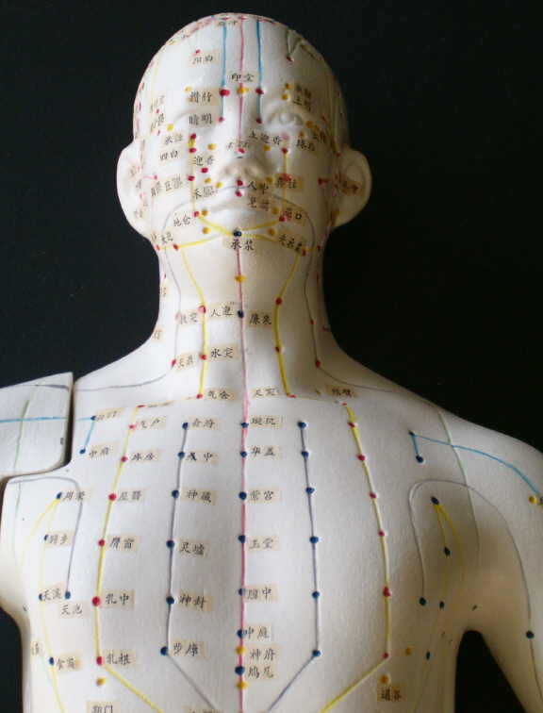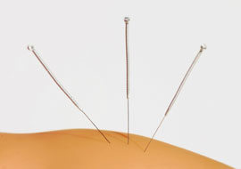  Tentative

DATE | TIME | CLASS | ROOM | FACULTY
 |  | Essentials of Acupuncture/ Clinical Intensive | 395 Lenox Rd
 |  | Weekend I
3/30/12 | 4 pm – 8 pm | ACU 1000 – Introduction to Acupuncture | Classroom 1A | Dr. Chao
3/31/12 | 9am -6pm | ACU 1010 – Theories of Traditional Chinese Medicine  ACU 1020- TCM Pathogenesis | Classroom 1A | Ms. Li
4/1/12 | 9am 6pm | ACU 1030- Diagnosis of TCM  ACU 1040 Syndromes Differentiation | Classroom 1A | Ms. Li
 |  | Weekend II
4/13/12 | 4pm – 8pm | ACU 1050 -Meridians and Point Locations | Classroom 1A | Dr. Chen
4/14/12 | 9 am-6pm | ACU 1050 -Meridians and Point Locations | Classroom 1A | Dr. Chen
4/15/12 | 9 am-6pm | Needle Points | Classroom 1A | Ms. Turek
 |  | Weekend III
5/5/12 | 9 am-6pm | Head and Facial Pain/ Respiratory Problems | Classroom 1A | Ms. Turek
5/6/12 | 9 am-6pm | Upper & Lower Extremities | Classroom 1A | Ms. Turek
 |  | Weekend VI
5/19/12 | 9am – 6pm | Spinal & Thoracic Pain/ Neurological Disorders | Classroom 1A | Dr. Cai
5/20/12 | 9am – 6pm | OB/GYN & Urological Problems | Classroom 1A | Dr. Cai
 |  | Weekend VII
6/2/12 | 9am – 6pm | Heart & Blood Problems | Classroom 1A | Dr. Cai
6/3/12 | 9am – 6pm | Psychological Disorders  Gastroenterology Disorders | Classroom 1A | Dr. Cai
TBA | 11am – 4 pm | Practical Review | TBA | Ms. Turek
 |  | Video Viewing & Web-based PowerPoint Lectures
  Theories of Traditional Chinese Medicine  TCM Pathogenesis  Diagnosis of TCM  Syndromes Differentiation  Meridians and Point Locations  WHO Recommended Symptoms  Needle Techniques | Head and Facial Pain/ Respiratory Problems  Upper & Lower Extremities  Spinal & Thoracic Pain/ Neurological Disorders  OB/GYN & Urological Problems  Heart & Blood Problems  Gastroenterology Disorders
Exam – TBA
Clinical hours (100) must be arranged by the last class in May. Note that clinical hours are schedule Saturdays and Sundays with occasional weekdays. You have two months to complete the clinical hours unless you make your own arrangement.

