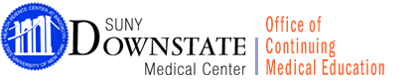OUTCOME SUMMARY FORM

At the end of the activity academic year, complete this summary and return to the OCME

Title of Activity
Date of Activity
Organization
Department
Activity Director
Indicate the number of participants who attended your CME activity | Number of physicians  Number of non-physicians
Indicate the number of sessions if this is an RSC
The following is based on participants evaluations, input from faculty, staff and yourself. | Strongly Agree | Moderately Agree | Disagree
The intended objectives of the CME activity were met.
The desired results or expected outcomes were achieved.
The topics presented had an impact on the audience to bring about behavioral changes in terms of a physician skill, performance in practice and/or patient care.
What were the major strengths and weaknesses of this activity?

Would you make any changes in future CME activities based on feedback from this activity?

Please use this space to provide a general summary of the activity.

I certify that all commercial support and speaker disclosure were made.

Activity Director Signature__________________________________ Date _________________

