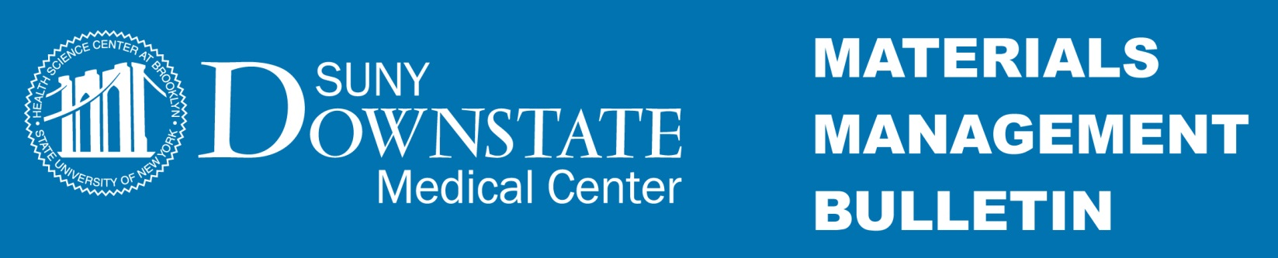
February 22, 2016 Bulletin # 16-80

Subject: State Fiscal Year End Payment Processing Deadline: March 11,2016
________________________________________________________________________________

To: The Downstate Campus

From: Martin J. Deane
AVP, Materials Management

In preparation for the New York State’s Fiscal Year end, the State Financial System (SFS) will not be available between March 30, 2016 and April 11, 2016. No payments will be issued during this time frame.

Purchase requisitioning will not be affected.

Please forward all approved invoices that need to get paid prior to the SFS shutdown to the Accounts Payable department (Mail Stop 54) by March 11th 2016. Please ensure that you inform the Accounts Payable department of any transactions that are currently pending and absolutely must be paid prior to the shutdown.

If you have any questions or would like further clarification, please contact Surbhi Shah, Executive Director of Accounts Payable at extension 1990 or Martin Deane, AVP of Materials Management at extension 3199.

Thank You

