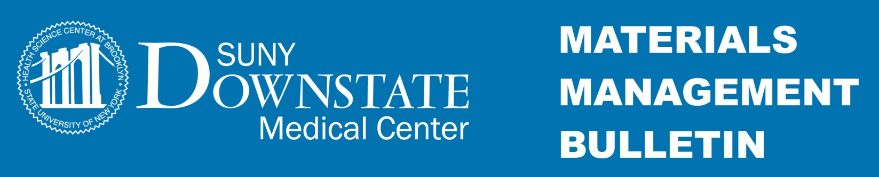

**January 20, 2016** Bulletin # 16-74

Subject: Procedure for Purchase Requisitions Chargeable to Fiscal Year 2016-17

**________________________________________________________________________________**

All approved **Blanket Order Purchase Requisitions** for Fiscal Year 2016-17 (7/1/2016 thru 6/30/2017) must be typewritten and submitted by **February 19, 2016** to the Contracts & Procurement Department (Mail Stop 63) for:

• commodities

• annual equipment service (i.e. copiers, equipment insurance program (REMI)

• software maintenance agreements

• other annual service agreements (i.e. bottled water, off-site record retention)

• contract encumbrances

Any **handwritten** Purchase Requisitions will be returned **unprocessed.**

The requisitions must encumber the total cost for the Fiscal Year 16/17and have all of the following information:

• Requisition Number

• Suggested Vendor, contact name and number

• Your Contact Information

• Item Description and Unit of Measure

• Estimated Quantity of Items Being Ordered (items should be listed in order of frequency)

• Value of each Product (this can be based upon a historical price)

• Account Code and Object Code

• All needed authorization/ approval Signature(s) for the Value of the Requisition.

Requisitions for service (consulting, equipment maintenance, software license) must also include:

• Start and end date (i.e. August 1, 2016 through July 31, 2017)

• Model #, Manufacturer and Serial # of equipment

• Indicate if BAA is required

Please be mindful that all transactions over $25,000 requires Minority/Woman-Owned Business Enterprise (MWBE) participation, over $50,000 that are not on a current contract must be advertised in the NYS Contract Reporter and all service contracts exceeding $75,000 must be pre-approved by both the Attorney General’s Office and the Office of the State Comptroller.

Further information: See links below or contact the Contracts & Procurement Department at 718-270-7214.

**Online Resources**:

Purchase Requisition form: [http://www.downstate.edu/procurement/documents/DMCPurchaseRequisitionFORM.pdf](http://www.downstate.edu/procurement/documents/DMCPurchaseRequisitionFORM.pdf%20)

How to fill out a Purchase Requisition: <http://www.downstate.edu/procurement/how-to.html>