October 23, 2009. SUNY Upstate Medical University has the following equipment available for transfer. These items will be available until Friday, October 30 and are pick-up only. If interested, contact:
Maryann Garbooshian
SUNY Upstate Medical University
Property Management
105 Madison Towers, Syracuse, NY 13210
Phone (315)464-5645
Fax (315)464-5648

Qty = 117 Stainless Steel cupholders -brand new.
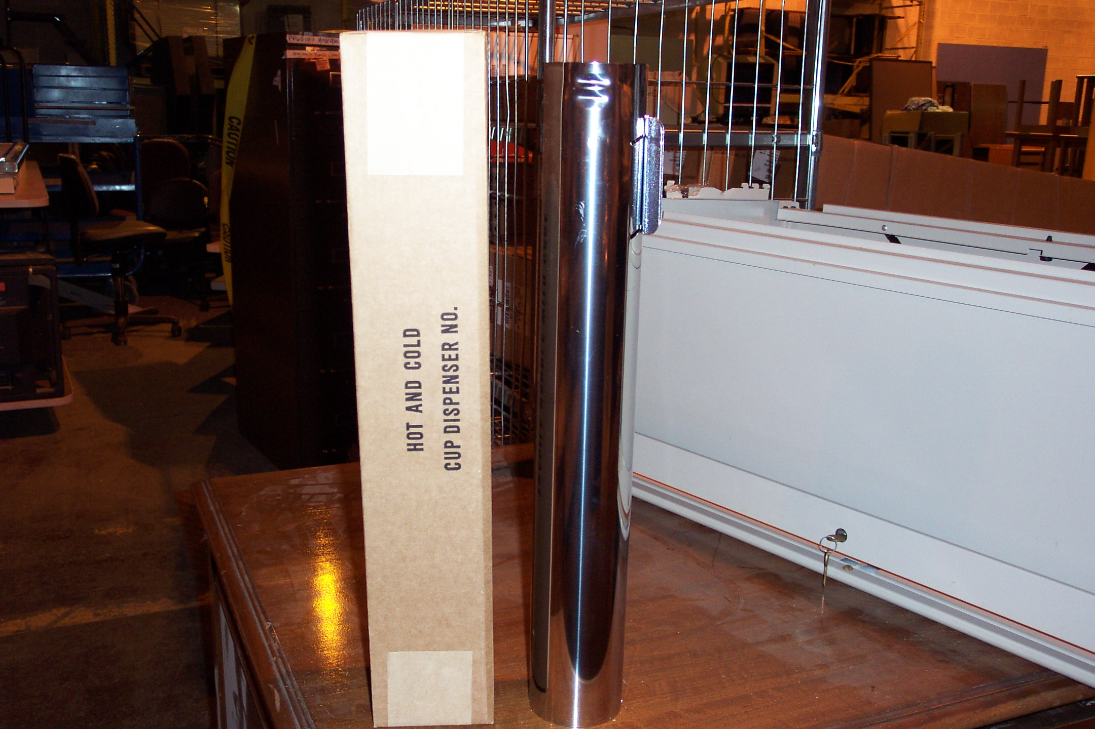

QTY =1 Coherent Ophthalmic Yag Laser System. Model 7970
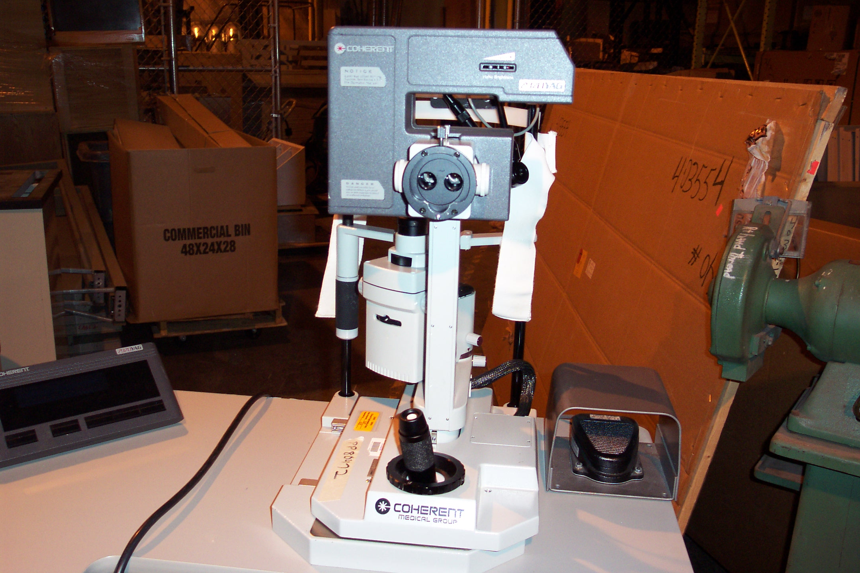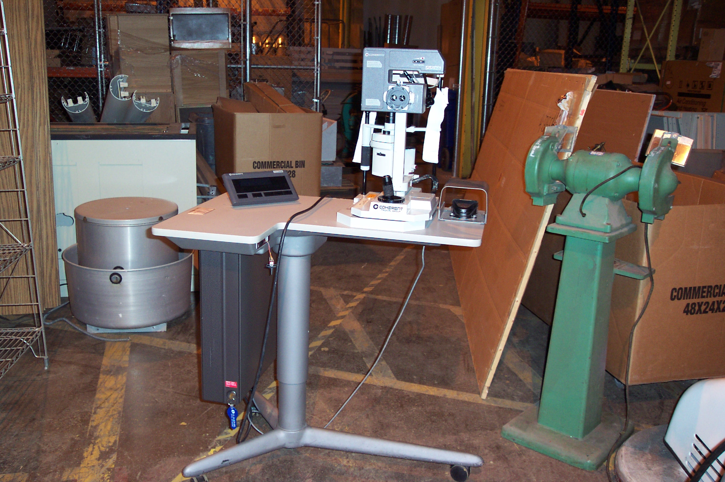

QTY = 2 Betco Power Buff Burnishers. These will need batteries.
